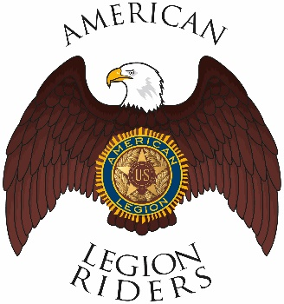

American Legion Riders Chapter 3, Hanford, CA
Minutes for March 8, 2022
Meeting called to order: The meeting was called to order @ 6:34pm. Prayer, Pledge of Allegiance and Preamble was said.
Officers Present: Director James Landolt, Asst-Director Frank Pightling, Treasurer Geni Lefler, Secretary David Darrow, Judge Advocate Pat O'Brien, Sgt-At-Arms Jack Alford, Road Captain Robert Stover. Excused: Chaplain Filly Reynolds

Members Present: Gustie Compton, Jon Bailey, Scott Day, James T. McCaw, John Ritter, Dan Rushing
Guests Present:
Review of Minutes: Motion to accept minutes for February 8, 2022, was proposed by Geni Lefler and 2nd by Pat O’Brien and ratified by members.
Committee Reports: None
Treasurer's Report:
Chaplain Report:
Unfinished/Old Business:
Bunko at 1pm 13 March, St. Patrick’s Day Dinner 6pm, take out available at 5pm. 9Am Set up.

This month’s ride to Three Rivers Dry Creek Road and Blossom Trail. 9am KSU.

CPR Qualifications are available for $35 at The American Red Cross online.

New Business:
Discussed upcoming elections and the need for nominations for Officers, nominations will begin in April meeting.
Gus opened discussion for having a slow rider skill workshop, we will investigate a place to do this.
Gus opened discussion for doing a Toys for Tots drive this year, we will look for partners for this.
4th of July booth is 4 months away, need security and help at the booth.
Good of the Riders:
Pat Obrien opened discussion about providing funding for the Post 3 Chaplain’s husband’s need for a special wheelchair. Discussion was held for amounts, Geni Lefler proposed a motion to give up to $1000 to this endeavor and seconded by Gus and ratified by members

Secretary will update website (www.alrhanford.com) first Saturday after monthly meeting and again the Saturday prior to the next meeting.

Pat O’Brien suggests looking into Brake Free light system for helmets. They can be found at
https://www.brakefreetech.com/products/brake-free

Remember to Ride Safe

Meeting adjourned at 7:43pm

